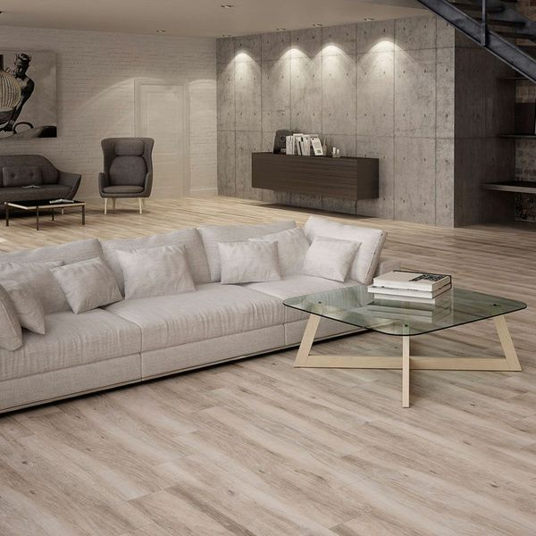

Parlor Fallow Walnut Wood Effect Tiles: <https://www.wallsandfloors.co.uk/parlor-wood-effect-tiles-fallow-walnut-tiles-14698>

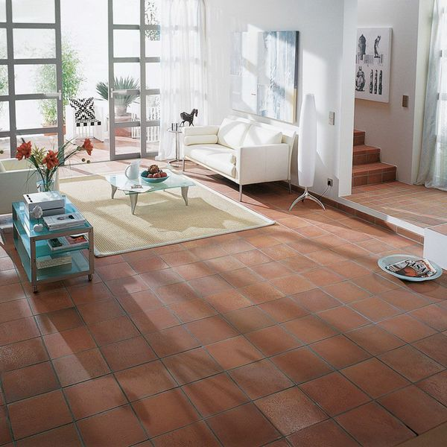

Aragon Flat Red Quarry Tiles: <https://www.wallsandfloors.co.uk/aragon-terracotta-red-quarry-tiles-flat-15x15-tiles>

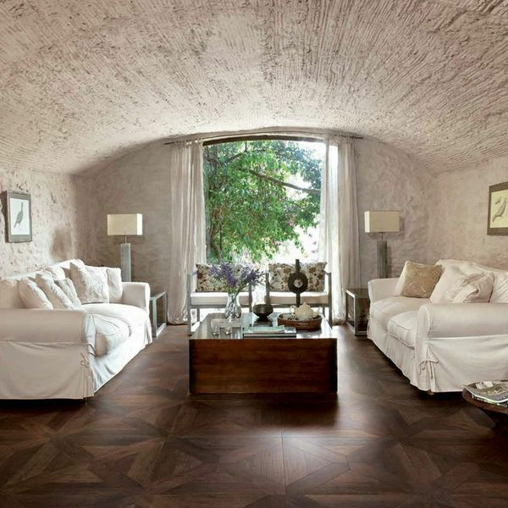

Vintage Wood Rovere Floor Tiles: <https://www.wallsandfloors.co.uk/vintage-wood-tiles-rovere-floor-tiles>

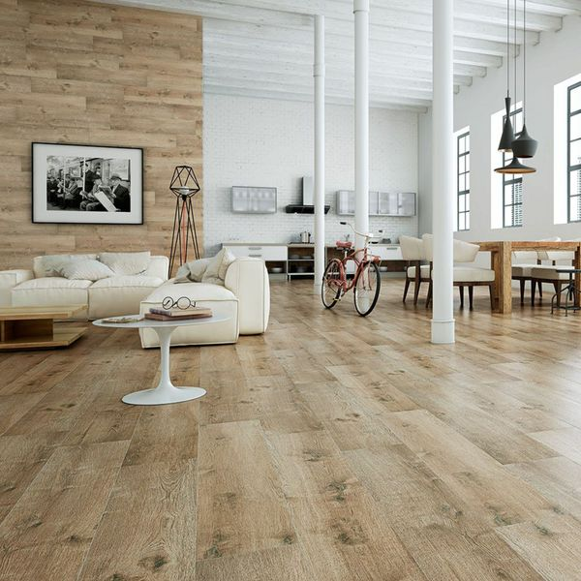

Madagascan Ipil Oak Wood: <https://www.wallsandfloors.co.uk/madagascan-ipil-tree-tiles-oak-wood-effect-tiles>

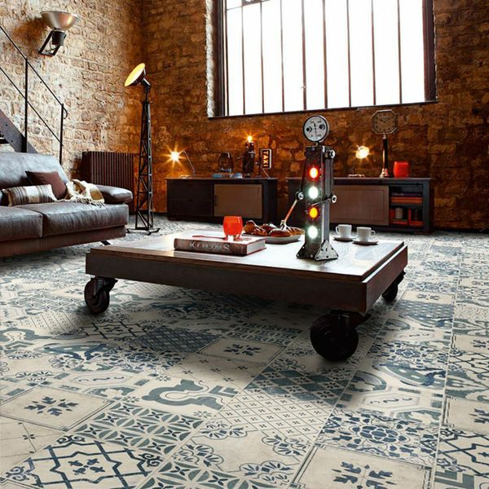

Tangier Antiqua Decor Pattern Floor Tiles: <https://www.wallsandfloors.co.uk/tangier-floor-tiles-antiqua-decor-floor-tiles>

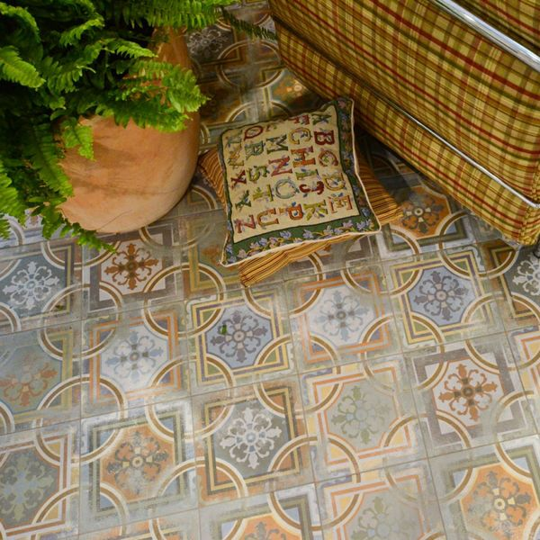

Comillas Patchwork Floor Tiles: <https://www.wallsandfloors.co.uk/comillas-patchwork-floor-tiles-20x20cm>